Orton Wistow Primary School



SEND Information Report

Status | Statutory | Date Agreed:
GB Monitor | SEND Governor | Headteacher: | Colin Marks
Staff Lead | SENCo | Chair of Governors: | Kirsty Cleworth
Senior Lead | Headteacher
Version | 1
Publication Date | Aut/25
Next Review | Aut/26

A guide to our provision 2025-26
Who can I speak to about my child?
If you have any concerns, we would first encourage you to speak to your child’s class teacher. They are always happy to share details of how your child is getting on and suggest extra support or resources that may be needed. You can also speak to the Special Educational Needs Co-ordinator (SENCo) to discuss your concerns.
The SENCo is Mrs Linda Harries. Mrs Harries is in school on a Tuesday, Wednesday and Thursday. You can also discuss any concerns with our Headteacher, Mr Colin Marks.

As an inclusive school, we offer the following ‘additional and different’ arrangements to support children with SEND. This provision is over and above ‘Quality First Teaching’ which is the entitlement for all children.

Children in our school will get support that is specific to their individual needs. This may all be provided by the class teacher or may involve:

- Advice and support from the School’s SEND Co-ordinator and other members of staff within the school.
How will we support your child?
Targets for your child and the provision in place to help them to achieve these, is shared with you each term on a Learning Plan. You will be invited to a meeting with the class teacher to discuss this.
If your child is in receipt of an Education, Health and Care Plan (EHCP), you will also meet annually with the SENCo to review this.
Class teachers track and monitor individual progress in core and foundation subjects each term.
Your child may also work with a Teaching Assistant (TA), a Speech and Language TA or a Learning Mentor. This will often be within the classroom, but at times includes working in a quiet break out space, in a small group or on a 1:1 basis. Sometimes we provide support during breaktimes and lunchtimes.
How does the school identify children with special educational needs/disability (SEND)?
Teachers can raise their concerns with the SENCo. We have a proforma for this, so that we have a record of the concerns and any recommendations that the SENCo may give based upon observations, any suitable assessments, advice from other professionals and parent/carer discussions.
Information may also be passed on to us from previous settings.



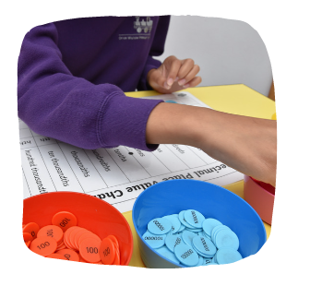
How will my child access the curriculum?
A range of activities, opportunities and approaches are offered to meet the needs of your child. We make adaptations and small change, so all children get the same opportunities.

Within the classroom, adult support is allocated by the teacher, based upon the activities set for each lesson. This may include some pre-teaching, regular check-ins to ensure your child is on task, short or extended periods of adult support, either in a small group or individually and addressing any misunderstandings and misconceptions that have arisen before the next lesson in a teaching sequence.


What opportunities are there to discuss my child’s progress?
Parents’ Evenings are held in the Autumn and Spring terms. An end of year report is also written, and parents can attend an Open Evening in the Summer term.
You will be offered a meeting each term, where you, the class teacher and your child, if appropriate, can discuss in detail their targets and agree the new ones.
We operate an open- door policy, so appointments can be made with class teachers and/or the SENCo at any time throughout the year. If you have concerns you would like to discuss, please contact the school office to arrange a meeting.

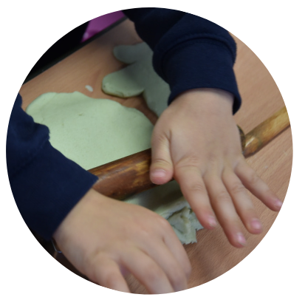
Is there support for my child’s well-being?
We have a whole school ethos which understands and supports children’s social and emotional needs. We know we must support these needs to ensure your child can engage fully with their learning. We have a dedicated and supportive staff team, who are trained in the approach of Emotion Coaching.
We have a Pastoral Team, who focus on working with your child individually or in a small group, if appropriate, to develop social skills and an understanding of their emotions. They can also support children who have undergone a bereavement, parental separation or any other ‘trauma’ that may have occurred.
Both members of the Pastoral Team are trained ELSAs (Emotional Literacy Support Assistants) who deliver ELSA interventions.

We have a consistent approach to behaviour management throughout school and a zero tolerance of bullying.
We also have Breakfast Club and After School Club provision on the school site, providing consistency for your child, if they attend.
We make good use of other professionals and will refer your child, if needed to the School Nursing team, the Mental Health Support Team, YOUnited, Families First and Young Carers.

Some pupils require an Individual Health Care Plan to help them manage medical conditions. We liaise closely with medical professionals to ensure this is effective.

How can my child share their views?
Pupils are encouraged to share their views with their class teacher and via the School Council. When teaching staff and the Senior Leadership Team carry out Learning Walks, they will always seek the views of several children on a variety of aspects of school life.
Children with an identified SEND complete a One Page Profile each term and share their views for the review of their Learning Plan. They are also welcome to attend the meetings to discuss these.
Pupils with an EHCP are asked to attend their Annual Review meetings, or part of it or to share their thoughts and feelings prior to the meeting with a trusted adult.
All pupils can attend Parents’ Evenings if they wish to.

Are there any specialist staff at Orton Wistow Primary?
Mrs Harries is responsible for supporting class teachers in how they can best support pupils in their class. She holds the National Award for SEN Co-ordination (NASENCO). She also holds a Level 1 qualification in British Sign Language.
Mrs Harries is supported by the Assistant SENCo, Mrs Rosie MacColl, who is an experienced teaching assistant. She has completed the ELKLAN ‘Speech and Language Support for 5-11, Level 3 qualification. Mrs Lewis also holds the EKLAN qualification and supports some of our younger children with their speech difficulties. Mrs MacColl leads on Speech and Language therapy within school and liaises closely with our Link NHS therapist. This year, Mrs Anita Lewis will take on some of the responsibility for working with children to complete SaLT recommendations. Mrs MacColl is also trained in using the Southfields pack and the Paston pack.
Our teachers and TAs do not hold qualifications in specialist areas, but many have experience and training related to meeting the additional needs of some of our pupils.
Training for our staff has recently included supporting externalised behaviours.

Mrs Hannah Wild and Mrs Lucy Fogg hold an Emotional Literacy Support Assistant (ELSA) qualification.


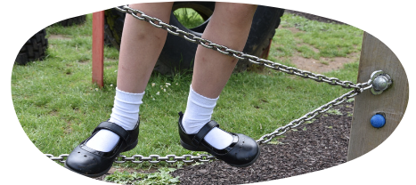


Specialist Provision
Over recent years we have developed our provision in school to best meet the needs of our pupils. This includes meeting their sensory and physical needs, their emotional wellbeing and mental health, as well as their learning needs.

We have a dedicated space, known as The Treehouse, that all children can access, if they need to. A safe space that children can use if they are finding it difficult to process their emotions and needs. This is something different from the classroom for a short period of time.

We have a sensory circuit set up throughout the morning for children to access. Children can also use our outside space for planned movement breaks. In the afternoon The Den is set up as a calm, chill out space for children who need some time to decompress.

We have another dedicated space, known as The Owls. This is an appropriate provision base that a small numbers of our pupils access; they are in receipt of an EHCP and have complex needs that are best met in this base.

The base is overseen by Mrs Harries and a team of SEND Teaching Assistants support throughout the day.

The pastoral team who supports children with Social, Emotional and Mental Health Needs (SEMH) are Mrs Hannah Wild and Mrs Lucy Fogg. We are fortunate that they are both trained ELSAs (Emotional Literacy Support Assistants).



What specialist services are accessed by OWPS?

Local Authority Services:
- Advisory Teacher Service (Autistic Spectrum Disorder, ADHD, Hearing, Visual or Physical impairment) LASS
- Parent Partnership Service
- The SEND HUBS
- The Early Help Team
- Educational Psychology Service

NHS Services:
- Paediatric Physiotherapy
- Occupational Therapy Service
- Speech and Language Service
- Community Paediatrician
- School Nurse
- Mental Health Support Team
- YOUnited

Independent Services:
- Support for Learning
- Alternate provision, such as OAK activities, Return2Learn
- Centre 33 for Young Carers

Charity Run Services:
- Barnardos Family Support Workers
- Domestic Abuse counselling via Women’s Aid
- Counselling from Little Miracles

Mrs Harries can refer to all these services.

Parents are now able to self-refer for a Parenting Course. Webster Stratton, TripleP and Stepping Stones are all part of the universal offer available on the Peterborough City Council’s Local Offer.

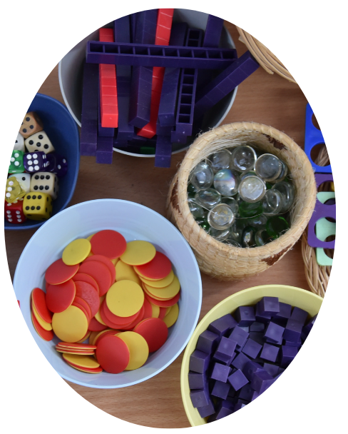

How is the school accessible to children with SEND?
We make every effort to overcome barriers, so that all pupils can access learning activities, day trips and residential visits.
Class teachers will liaise with parents and carers on suitable adjustments to improve access to activities and will draw up personal risk assessments if necessary.
We are an accessible site and have toilet and changing facilities to meet the needs of our children.
More information can be found in our Accessibility Policy and Plan.



What are our admission arrangements for children with Disabilities?
The arrangements for the admission of pupils with Special Needs or disabilities to gain admission as pupils to Orton Wistow Primary School fall within our duties under the Equality Act 2010 and are the same as those applied to all pupils. Admission is in the first instance arranged by application to the Local Education Authority. If successful, we then receive notification that a child has been allocated a place at Orton Wistow Primary School.
For admissions please visit:
Apply for a school place- Peterborough City Council

How does the Governing Body support pupils with SEND?
We have a Governor, who oversees the SEND Policy and ensures that our provision reflects the changing needs of the school and complies with our statutory responsibilities.
They have an overview of our SEND budget and how we allocate the funds within school.
They meet Mrs Harries, the SENCo, every term to discuss how things are in school and prepares a report to be shared with the full Governing Body.

How are the school’s resources allocated?
Overall budget decisions are made by the Headteacher and Governing Body.
The budget is firstly allocated to the commitments outlined in EHCPs and in meeting recommendations made by other professionals.
Resources are then allocated and matched to pupils’ SEN needs through careful planning and monitoring by the class teacher, SENCO and the Senior Leadership Team to provide targeted support for some pupils based upon their current attainment and recent progress.
How can parents/carers give feedback?
There are many opportunities throughout the year when you can give us your feedback. These include contributing to the Learning Plan meeting each term, parent consultation evenings, the opportunity to meet with the class teacher, SENCo or Headteacher at any time and Annual Review meetings for children in receipt of an Education, Health and Care Plan.
We also encourage parents to give us feedback via the Parent Questionnaires.
If parents /carers feel they need to make an official complaint, they can do so by following the School’s Complaints Procedure outlined on the school website.

Transitions at OWPS
If your child is joining us in Reception, an information evening is held in the summer term, so that key members of staff can introduce themselves and you can receive vital information about your child’s start at school. Your child will visit the school for ‘play’ sessions during the summer term. Early Years staff make visits or hold telephone conferences to pre-school settings to liaise with keyworkers; they also organise a home visit to meet you and your child in a place where they feel safe and comfortable. This is a time to share individual concerns or worries. Additional visits are organised for individual children where it is considered necessary and helpful for their transition.
Transition meetings with the SENCo from the current setting and Mrs Harries also take place. These can include parents/carers and other professionals where this is appropriate. Early Help Assessments are also transferred to us.
We also offer a curriculum evening in the first week of the Autumn term, when the Early Years staff outline what learning looks like in the Reception year, including phonics, early reading and writing and maths.
If your child joins us in other year groups or mid-year, we liaise with your child’s previous school and records will be transferred. A meeting will be offered if your child has high needs and tours of the school can be arranged with Mrs Harries.

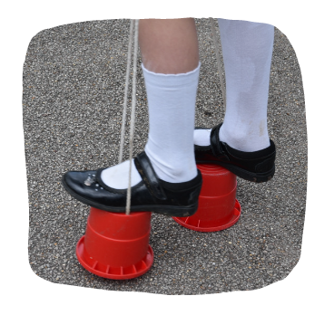
What will happen when my child leaves OWPS?
If your child is leaving us to join a local secondary school, we arrange for staff from the receiving school to visit our school. Transition meetings are held with the Y6 teacher and secondary school staff, and SENCo, where appropriate. The SENCo arranges for the transfer of relevant information to the receiving school.
Your child will participate in ‘Move up’ days at their new school. Additional visits can be organised, if necessary. Other arrangements may be necessary, such as photo books, meeting key staff and Social Stories to ensure there is a smooth transition.
If your child moves mid-year or out of the local area, we try our best to liaise with your child’s new school and to transfer relevant school information.

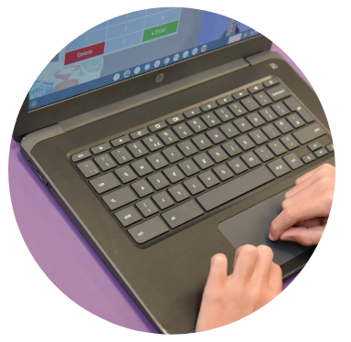
External support for information and advice
- SEND Information Advice Support Service – Tel. 01733 863979
- Email: pps@peterborough.gov.uk
- Peterborough LA Educational Psychology Open Access
Consultation Service – Tel. 01733 863689
- Peterborough LA Autism and ADHD Advisory Teacher Service
- (AATS) Open Access Consultation Service
- City Council SEN Website, including the Local Offer:
https://fis.peterborough.gov.uk/kb5/peterborough/directory/localoffer.page?familychannel=8

